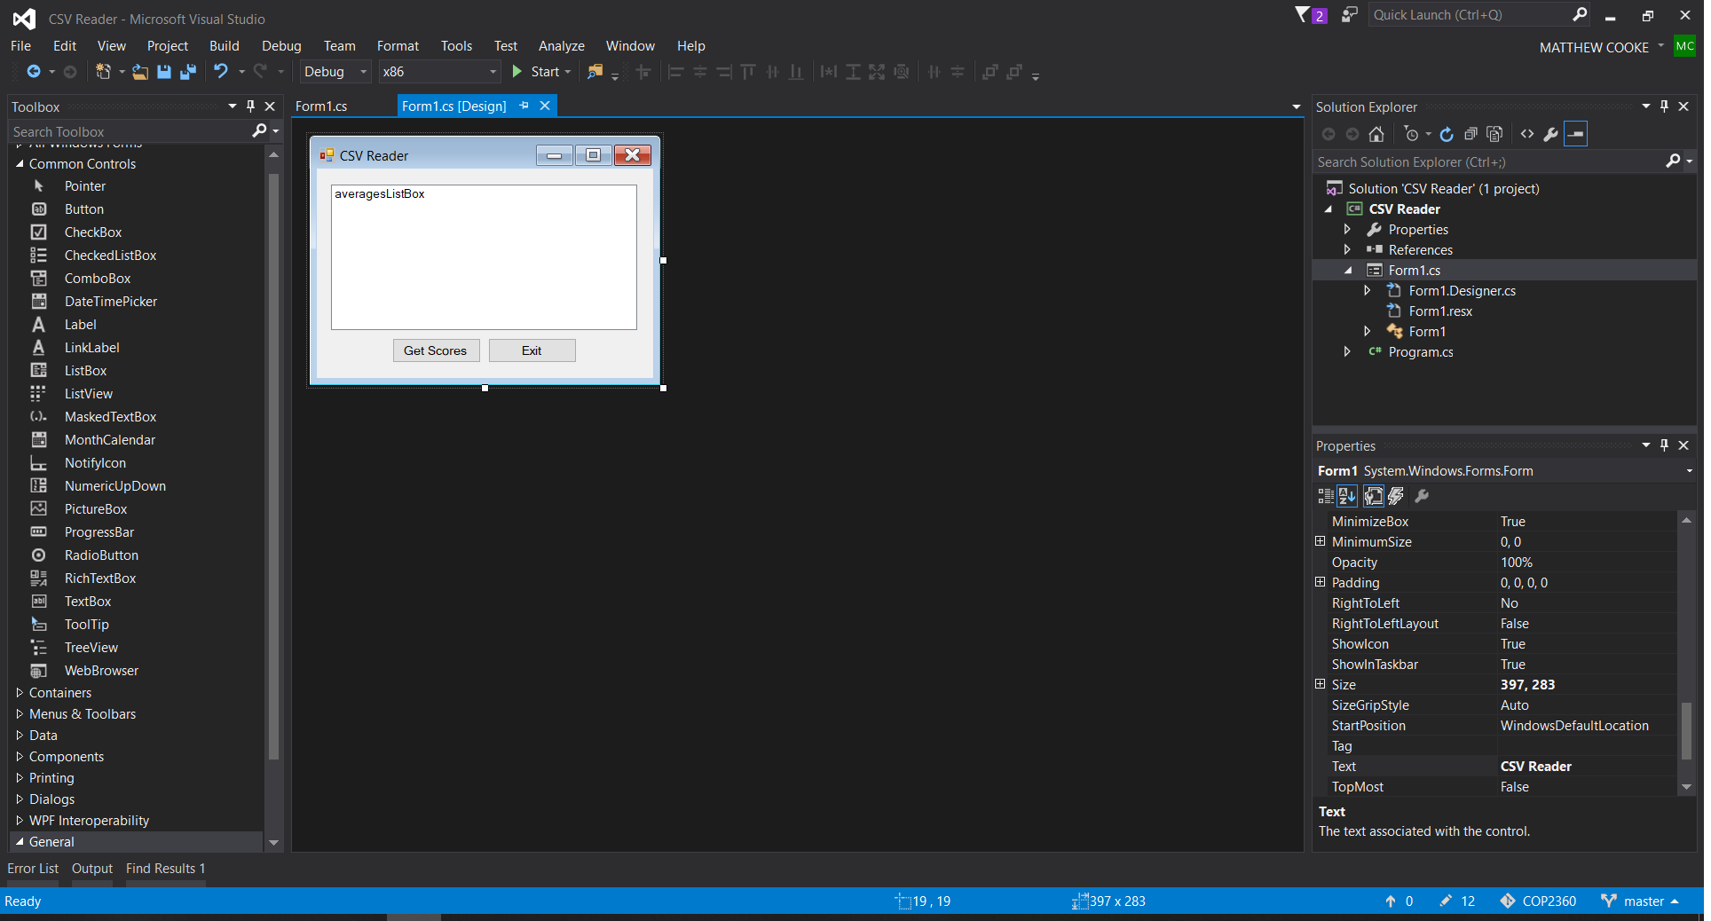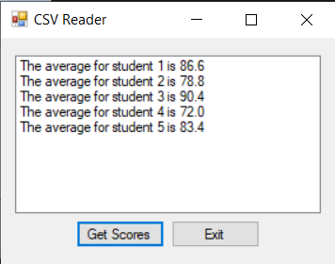

using System;

using System.Collections.Generic;

using System.ComponentModel;

using System.Data;

using System.Drawing;

using System.Linq;

using System.Text;

using System.Windows.Forms;

using System.IO;

namespace CSV_Reader

{

public partial class Form1 : Form

{

public Form1()

{

InitializeComponent();

}

private void exitButton_Click(object sender, EventArgs e)

{

this.Close();

}

private void getScoresButton_Click(object sender, EventArgs e)

{

try

{

//Declare variables

StreamReader inputFile; //to read the file

string line; //to hold each line of the CSV

int count = 0; // to hold the student counter

int total; // accumulator for the sutdent scores

double average; // Avg for each student test score

//create a delim array

char[] delim = { ',' };

//open the CSV file

inputFile = File.OpenText("Grades.Csv");

while(!inputFile.EndOfStream)

{

//increment the student counter

count++;

//Read each line of the file and assign it to line

line = inputFile.ReadLine();

//get the test scores as tokens from the file

string[] tokens = line.Split(delim);

//SO I learned a lesson by trying to declare the value of the total as 0

// without realizing that it was necessary to clear out total for each student

total = 0;

//calc the value of each line to get the total

//for the test scores

foreach (string str in tokens)

{

total += int.Parse(str);

}

//calculate the average for each line based

// on the number of tests and their totals

average = (double)total / tokens.Length;

//display the average in the list box before moving to the next

averagesListBox.Items.Add("The average for student " + count + " is " +

average.ToString("n1"));

}

//close the file

inputFile.Close();

}

catch(Exception ex)

{

MessageBox.Show(ex.Message);

}

}

}

}